

KINBASE BUSINESS SOLUTIONS

Manual

October 14, 2017

# Table of Content

OVERVIEW------------------------------------------------------------------------------------------- P. 2

CREATE A BUSSINESS ACCOUNT----------------------------------------------------------------P. 2

HOW TO MANAGE CUSTOMER IN THE CUSTOMER CARE CENTER--------------------P. 3

ADDING CUSTOMER TO YOUR DATABASE---------------------------------------------------P. 4

ADDING AGENT/EMPLOYEE/BUSINESS SUPPLIERS----------------------------------------P. 6

ADDING LOCATION--------------------------------------------------------------------------------P. 6

UPDATING CUSTOMER INFORMATION-------------------------------------------------------P. 6

ADDING NEW SERVICE---------------------------------------------------------------------------P. 8

CREATING BUSINESS DIGITAL /WEB PAGE --------------------------------------------------P. 10

UPLOADING IMAGE-------------------------------------------------------------------------------P. 12

CREATING A CUSTOMER DISCLOSURE-------------------------------------------------------P. 13

GENERATION REPORTS--------------------------------------------------------------------------P. 13

GROUP ACTIVITY MANAGEMENT-------------------------------------------------------------P. 14

# Kinbase overview

Kinbase Business Solution allows you to create a customer database to manage your customer records that is essential to keep your business growing and engaging 24/7 through Customer Relationship Management and digital presence in a few steps.

How to create your own business Database

To start creating your database and customer relationship page, follow the steps below

1. On Kinbase.com click on business Solution
2. Click on “Create Business Database”

Create Business Database fig. 1

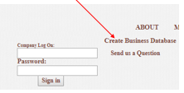

Choose the category most appropriate to your type of business, and click on create

Business Category fig. 2

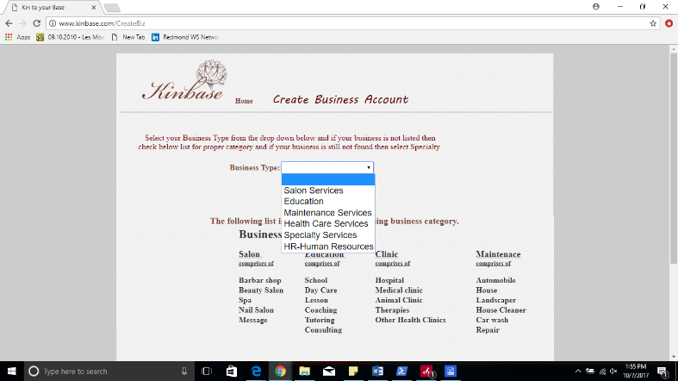

You will now be prompted to enter your business’ information. Double check email and password before clicking on Create.

Entering New Customer fig. 3

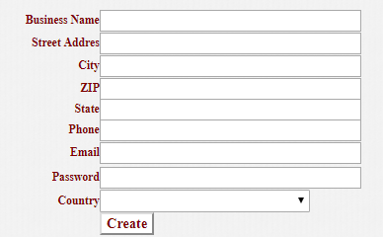

After you have created your email you will receive an email and a confirmation page. Click Continue to be redirected to the login page. Enter your email/password that you entered when you created your business. Once logged in you have access to your main Customer Management page

At this point you should be at the “Customer Care Center”

How to manage Customer in Customer Care Center

This is where you will manage your customers and services

Home:- This link will take you to Kinbase business Home page

+Customer:- This allows you to add a new customer to your database

+Service Agent: This allows you to add employees, suppliers and anyone you do business with.

+Location: This allows you to add more of you business location

Payment:- These are the recommended merchant services you could subscribe to for your business depends on which one is available in your country.

Customer Zip /Province: This allows you to search for customers by Zip or Province. Depends on which is customary to your country.

Customer Phone No:- Alternatively to Zip/Province, you can use phone number to pull up a customer.

Report: This link will take you to a page where you could pull up any canned report that we have written for your business or you could request for a customized report through this page

Web page:- This allows you to create a web presence for your business and have the link printed on your business card or email to your customers

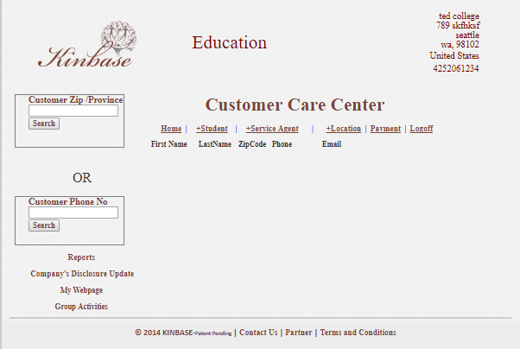

### Adding agents

Clicking on Service Agent, allows you to add customer facing employees and business partners. Enter your employee name then click exit when finished. This screen also allows you to enter your business location but you have to do one at a time.

To Add a staff member or business partner to your database,

Add Agent fig. 6

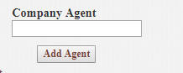

1. Login with your email and password
2. Click on “+ Agent”
3. Enter Staff’s name
4. Click on Add Agent
5. Click on exit when done

Adding Location

To Add Location to your database, follow the steps below

1. Login with your email and password
2. Click on “+ Location”

Add Location fig. 7

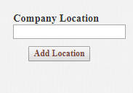

1. Enter Location name
2. Click on Add Location
3. Click on exit when done

Add Customer to Your Database

To add a customer to your Database, follow the steps below

Before entering customer data, ensure that you have already added service agents (employees) and Business Location as you will need that information to populate in a pull down box.

Add customer fig. 8

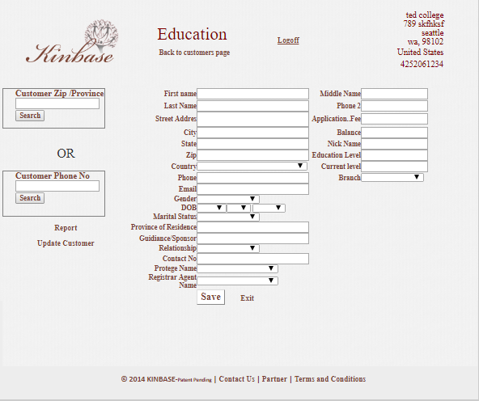

1. Login with your email and password
2. Click on “+ Customer”
3. Enter Customer Information
4. Click Save

Field Definitions

First Name: Customer’s First Name

Last Name/ Surname: Customer’s Last Name or Surname

Street Address: Customer’s address

City: City where customer resides

State: State where customer resides

Zip/Province: Zip code or Province and if not available enter NA

Country: Country where customer resides

Phone: Customer phone number

Email: Customer’s email

Gender: Gender/sex of the customer or enter NA if unknown

DOB: Date of Birth and if not needed give approximation or create a generic one for all

Marital Status: marital status of student/student’s parents

Province of residence: province or state customer resides in

Guidance/sponsor : Parents/sponsor of student

Contact number: Sponsor’s phone number

Protégé name: Student name if underage

Registrar: School administration agent responsible for keeping student records

Middle name: Customer’s middle name

Phone 2: Alternate contact number

Application fee: Program/course fee

Balance: Balance remaining on student’s account. If fees are paid in full, enter 0

Nickname: Customer’s preferred name if different than first name

Education level: Customer’s level of completed education

Current level: Customer/Student’s actual level of education

Branch: Location of program customer is attending

# Managing customer records

### Updating Customers

To update customer information, From the “Customer Care Center” , follow the steps below

To Update your Customer information, follow the steps below

1. Login with your email and password
2. Search for the customer with phone or Zipcode/Province
3. Click on the customer’s name
4. Click on “Update Customer” on the left
5. Make changes as needed Note: Appointment cannot be empty. You will need to enter today’s date if appointment is not needed at this point.

Click on Update to save the information you just entered

Customer Update Screen fig. 9

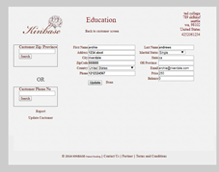

Adding A New Class for a Customer

To add A new class/course,

1. Login with your email and password
2. Search for the customer with phone or Zipcode/Province
3. Click on the customer’s name

You will be presented with screen below

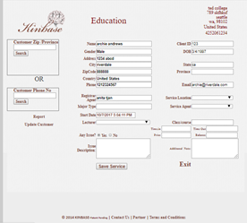

As you can see, the screen is halfway populated with customer information. Start to enter available information into the empty spaces below the blue printed note.

Major type: Major course of study the student is completing (ie: Architecture, Computer Science….)

Start Date: Start date for the course or class

Lecturer: Name of Instructor teaching the class/course

Service Location Location the class/course will take place

Service Agent: Employee or business partner who provides the class/course

Class/Course: Name of the class/course customer is attending

Time In: The time customer checked in

Time out: The time customer finish

Price: This is the service charge. If not charge enter 0 (zero)

Balance: This is the balance to be paid if nothing, enter 0 (zero)

Click on Save upon completion: This allows you to save the information you just entered

Exit: This exit you to the “Customer Care Center”

Webpage Creation

To create your business advertising page that you can update as needed to brand your business, click on My Webpage.

1. Column 1: This column one allows you to add list of items or services that your business provides and your

business address

1. Column 2: You will be able to Add titles and paragraphs in column 2

Web design page fig. 11

Column 2

Column 1

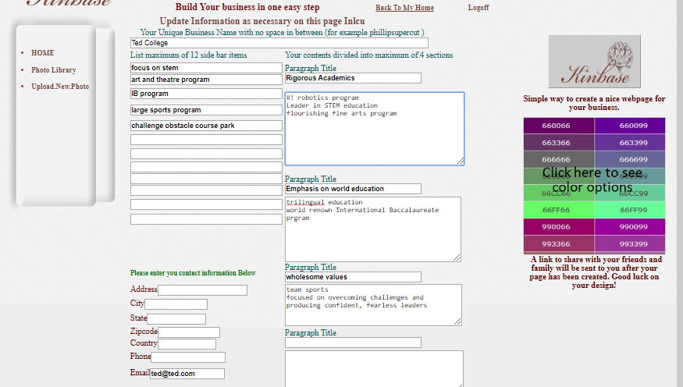

1. Background Color: You will be able to choose background color
2. Font color: You will be able to choose font color

Choose Page color fig. 12

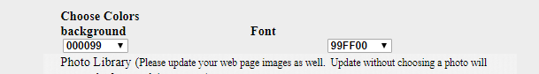

1. Images: You will be able to add up to 4 images. For best result make sure your photo is square

If less than 4 images are added kinbase logo will replace missing image(s). Number your image in the order you want it to show on your page. You will be able to update your page at any time as you desire. See figure below.

Uploaded Image fig. 13

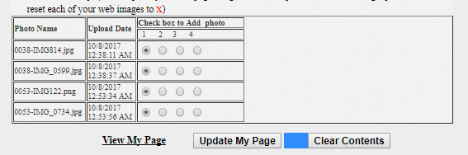

You may can arrange your images in any order you want it to appear on your webpage such as this

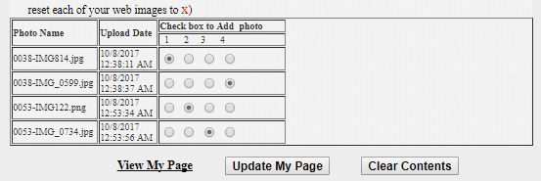

1. View My Page: This allows you to see the webpage you just created. A link will be sent to your email registered on your account
2. Update My Page: This will update your changes and display your updated page. A link will be sent to your email registered on your account

Image Upload

To upload Image,

1. click on “Upload New Photo” (Note your image will need to be approve before it can be made available in your account)

Upload link fig. 14



1. Browse to the folder that contain your image (please read instruction below carefully)

Browse for file fig. 15

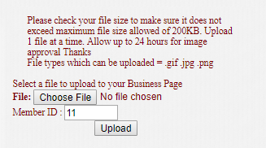

1. After you have browsed to your file, click on upload and wait for our Agent to review and release before use.

### Company Disclosure

Disclosure is the information you have for your customer to read and agree to before performing a service to them. It is an optional thing if your company needs one, you will be able to note that on the customer account.

To have one on file for you customer click on Company Disclosure (bottom left hand corner of Customer Care Center).

Sample notice:

“Informed Consent: Choosing a counselor is an important choice among the many you have, to support yourself. Counseling is not easy and has both benefits and risks. The benefits may include an increased capacity to manage your emotions, greater self-awareness, improved communication with significant others, reduced interpersonal stress, a higher level of self-esteem and confidence, greater ability to manage work-related stress, higher levels of self-direction and focus, and positive experiences of satisfaction and fulfillment. The risks may include experiencing the discomfort of self-disclosure, shifts in significant relationships, and feelings of depression, grief, anger, disappointment, remorse, and regret. You may also experience anxiety from making changes in your life as you develop and act on new patterns of thinking-feeling-behavior. Some clients require only a few sessions to achieve their goals, while others benefit from long-term counseling. You have the right to terminate counseling at any time; however, it is understood that premature termination may result in the return or worsening of the initial problems and symptoms. Please be informed that I cannot offer you a promise about the results of your therapy. I encourage you to talk with me directly if you are dissatisfied with my services, want a second opinion or referral, or if you are intending to discontinue appointments. If I am not able to resolve your concerns, you have the right to file a complaint with the Department of Health regarding any unprofessional conduct on my part.”

## Generating reports

To view global or individual customer data at a glance, click on the reports button located in the bottom left hand corner of your page.

The Reports Dashboard is used to host all your reports both the canned report or customized report for your company only. To receive export of any report on the dashboard please contact us or contact your business agent.

Clicking on the dropdown box allows you to choose between total customer data, monthly data, weekly data and daily data. This allows you to track services/growth as needed.

To view individual customer data, you will need the customer’s ID number. This ID can be found in the “Customer Care Center” by searching on phone number.

The Customer Record will show complete customer data at a glance, including address, phone number and DOB.

Customer Services will show you a history of the services a customer has received. Use Customer Service to view your customer’s history and provide customized service, helping generate customer loyalty.

Should you need any additional data, request customized reports by selecting New Report. Provide as much information as possible about the data and type of report you need, as well as your contact information so the systems administrator can contact you to provide your customized report or request additional information.

Group Activity Management

Group Activity Management Function is used to collaborate and keep customer informed as needed. You can use this page to market a new product to your customer base. To keep note on a customer without rendering service. It can be used as a reminder tool. To access **group activities** (in the bottom left hand corner) . there are two main function.

*Group Activities can be used to tag a note to your customer.*

*Group Activity fig. 16*

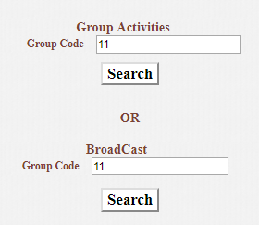

*To enter activity, click on “Group Activities” above*

*You can pull up a subset of customers with just phone number or Zipcode/Province*

*Note: To have the comments saved you must select Yes in the update column*

*Activity Note Page fig. 17*

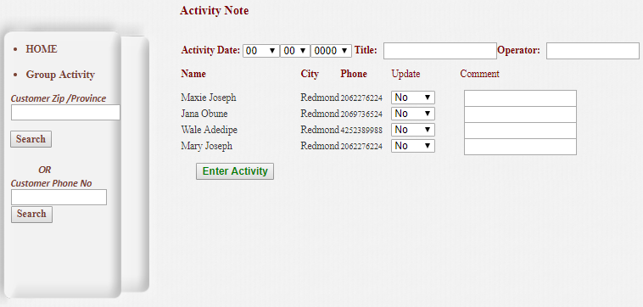

*Activity Date: The date of this Comment*

*Title: Title of the comment. You can enter NA if none*

*Operator: Agent entering the information*

*Broadcast can be used to create email to be sent to your audience and it can also be used as a blackboard or chat room for your employees.*  Broadcast page allows you to create email to be sent to customer(s).  To create an email, fill in the subject and type your text in the message area.

Click on “Save Broadcast” to have your email created

Email Creation Page fig. 18

You will be able to pull up a customer by phone No or Zip/Province

Send To: This allows you to send email to a customer or group by searching through phone No or Zipcode/Province in your database. The email that you click on to get to this page below will be sent to anyone you selected “Yes” on. After you have click on send email, the application will return you to Group Activity.

Post: This allows you to add more comment to your email

View: This allows you to view and read your email message(s)

Delete: This will delete email that is no longer needed